|  |
| --- |
| **DEPARTMENT OF ELECTRONIC AND COMMUNICATION**  **JAYPEE INSTITUTE OF INFORMATION TECHNOLOGY, NOIDA**  **MINOR-I REPORT SUBMISSION** |
| **SIGN LANGUAGE INTERPRETER** |
|  |
| **201526-17225118-1125-logo.jpg**  SUBMITTED BY :  **MITUL MEHROTRA(13102272)**  **ITIKA SOOD(13102273)**  SUBMITTED TO :  SUPERVISOR:  **Mrs. SHRUTI SABHARWAL**  EXAMINER:  **Mr. SHIVAJI TYAGI**  **CONTENTS** |
| |  |  |  | | --- | --- | --- | | S.NO | TITLE | PAGE NO. | | 1. | Certificate | 3 | | 2. | Acknowledgement | 4 | | 3. | Summary | 5 | | 4. | Introduction | 6 | | 5. | List of Figures | 7 | | 6. | Components and Apparatus required | 8 | | 7. | Hardware description |  | | 7.1 | Arduino | 9-13 | | 7.2 | Flex sensor | 14-17 | | 7.3 | Accelerometer | 18-20 | | 7.4 | LCD | 21-23 | | 8. | Project approach | 24-26 | | 9. | Budget and Cost | 27 | | 10. | Applications | 28 | | 11. | Conclusion | 29 | | 12. | References | 30 | |
|  |

|  |
| --- |
|  |

**CERTIFICATE**

# This is to certify that the work titled “SIGN LANGUAGE INTERPRETER” submitted by “MITUL MEHROTRA(13102272)&ITIKA SOOD (13102273)” in partial fulfillment for the award of degree of B-TECH of Jaypee Institute of Information Technology, Noida Sec-62 has been carried out under my supervision. This work has not been submitted partially or wholly to any other University or Institute for the award of this or any other degree or diploma.

Signature of Supervisor ……………………..

Name of Supervisor:**Mrs. SHRUTI SABHARWAL**

Date ………………………

**ACKNOWLEDGEMENT**

We have put tremendous efforts in making this project. However, it would not have been possible without the kind support and help of our mentor respected **Mrs.SHRUTI SABHARWAL**. We are grateful to her for providing every possible help.

We also extend our grateful thanks to **Mr. SHIVAJI TYAGI**for evaluating our project.

We would also like to extend our thanks to our H.O.D **Dr. R.C. Jain** for his underlying faith in us and making us believe in ourselves.At last, we would like to express our gratitude towards our parents & members of JIIT for their kind co-operation and encouragement which helped us in completing this project.

Our thanks and an appreciation also goes to our colleagues in developing the project and people who have willingly helped us with their abilities.

Signature of the student ……………………..

Name of Student:**MITUL MEHROTRA(13102272)**&**ITIKA SOOD(13102273)**

Date ……………………..

**SUMMARY**

The aim of my project “**SIGN LANGUAGE INTERPRETER**” is to provide a practical way of translating sign language into speech, offering people with vocal disabilities a means of communication with people incapable of understanding sign language. Firstly, we surveyed the existing communication aid systems and then found a cheap and easy way for interpreting the gestures to help deaf and dumb people communicate with ease. We successfully interpreted the 26 alphabets of English language and also used this system to convert the gestures to their respective meanings like food, ok, fine. Hardware components which we have used for this purpose are flex sensors, accelerometer, LCD and Arduino (microcontroller). A motion capture system is used for sign language conversion. It captures the signs and dictates on the screen as writing.

__________________ __________________

Signature of Students Signature of Supervisor

**INTRODUCTION**

**Working on Communication aid**

Since their existence, humans have been physically and mentally challenged with various impediments that hinder their advancement on all economical, political, and social levels. Statistics around the world show a relatively high rate of people with speaking difficulties. Rates extend to an average of 9% of the whole population, whether in the Middle East, Europe, Africa, America, or other continents of the world.

It would be unjust for such people to be excluded from society just because they lack elementary communication means. They are mentally capable individuals who deserve and are even demanded to play an effective role in society. Society cannot dismiss whatever potential they have, simply because it needs it; for it is known that society advances only with the collective effort of all of its members. To this end, technology is utilized to aid humans in their collective effort to overcome such impediments.

In this report, we present a system that enables mute people to further connect with their society and aids them in overcoming communication obstacles created by the society's incapability of understanding sign language.

The system we propose is based on translating motion to their respective sign. It suggests an approach involving human gesture and sign language recognition via a glove that assimilates these gestures and signs to display their equivalent word or alphabet.

**LIST OF FIGURES**

|  |  |  |
| --- | --- | --- |
| S.NO | FIGURE | PAGE NO. |
| 1. | Arduino | 9 |
| 2. | Atmega 328 pin diagram | 13 |
| 3. | Flex sensor | 14 |
| 4. | Working of flex sensor | 17 |
| 5. | Accelerometer | 18 |
| 6. | Axis measurement of accelerometer | 19 |
| 7. | 16*2 LCD | 21 |
| 8. | LCD pin diagram | 22 |
| 9. | LCD interfacing | 22 |
| 10. | LCD interfacing with arduino | 23 |
| 11. | Project approach |  |
| 11.1 | Sign language chart | 24 |
| 11.2 | Gestures | 25-26 |

**COMPONENTS REQUIRED**

* Arduino
* Flex Sensors
* Accelerometer
* LCD 16X2
* LEDs
* Breadboards
* Connector Pins
* Jumper Wires
* Connecting Wires
* Cardboard
* White paper

**APPARATUS REQUIRED**

* Arduino Software

**HARDWARE DESCRIPTION**

* **ARDUINO[3] :**

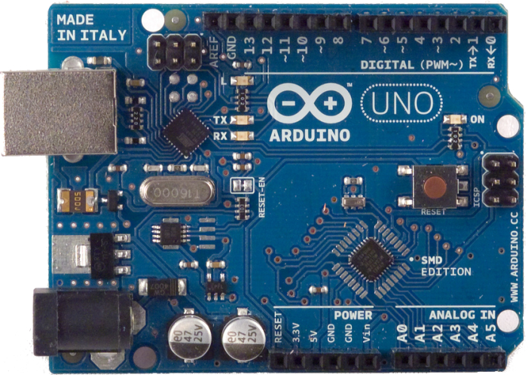

Fig. 1 Arduino Uno microcontroller Courtesy: Google images

The Uno is a microcontroller board based on the [ATmega328P.](http://www.atmel.com/Images/doc8161.pdf)It has 14 digital input/output pins (of which 6 can be used as PWM outputs), 6 analog inputs, a 16 MHz quartz crystal, a USB connection, a power jack, an ICSP header and a reset button. It contains everything needed to support the microcontroller; simply connect it to a computer with a USB cable or power it with a AC-to-DC adapter or battery to get started.. You can tinker with your UNO without worrying too much about doing something wrong, worst case scenario you can replace the chip for a few dollars and start over again.

**Power**

The Uno board can be powered via the USB connection or with an external power supply. The power source is selected automatically.

External (non-USB) power can come either from an AC-to-DC adapter (wall-wart) or battery. The adapter can be connected by plugging a 2.1mm center-positive plug into the board's power jack. Leads from a battery can be inserted in the GND and Vin pin headers of the POWER connector.

The board can operate on an external supply from 6 to 20 volts. If supplied with less than 7V, however, the 5V pin may supply less than five volts and the board may become unstable. If using more than 12V, the voltage regulator may overheat and damage the board. The recommended range is 7 to 12 volts.

**Input and Output**

Each of the 14 digital pins on the Uno can be used as an input or output, using [pinMode()](https://www.arduino.cc/en/Reference/PinMode),digital Write, and [digitalRead()](https://www.arduino.cc/en/Reference/DigitalRead) functions. They operate at 5 volts. Each pin can provide or receive 20 mA as recommended operating condition and has an internal pull-up resistor (disconnected by default) of 20-50k ohm. A maximum of 40mA is the value that must not be exceeded on any I/O pin to avoid permanent damage to the microcontroller.

In addition, some pins have specialized functions:

* Serial: 0 (RX) and 1 (TX). Used to receive (RX) and transmit (TX) TTL serial data. These pins are connected to the corresponding pins of the ATmega8U2 USB-to-TTL Serial chip.
* External Interrupts: 2 and 3. These pins can be configured to trigger an interrupt on a low value, a rising or falling edge, or a change in value. See the attachInterrupt() function for details.
* PWM: 3, 5, 6, 9, 10, and 11. Provide 8-bit PWM output with the analogWrite() function.
* SPI: 10 (SS), 11 (MOSI), 12 (MISO), 13 (SCK). These pins support SPI communication using the SPI library.
* LED: 13. There is a built-in LED driven by digital pin 13. When the pin is HIGH value, the LED is on, when the pin is LOW, it's off.
* TWI: A4 or SDA pin and A5 or SCL pin. Support TWI communication using the Wire library.

The Uno has 6 analog inputs, labeled A0 through A5, each of which provide 10 bits of resolution (i.e. 1024 different values). By default they measure from ground to 5 volts, though is it possible to change the upper end of their range using the AREF pin and the analogReference() function.

There are a couple of other pins on the board:

* AREF. Reference voltage for the analog inputs. Used with analogReference().
* Reset. Bring this line LOW to reset the microcontroller. Typically used to add a reset button to shields which block the one on the board.

**Technical specs**

|  |  |
| --- | --- |
| Microcontroller | [ATmega328P](http://www.atmel.com/Images/doc8161.pdf) |
| Operating Voltage | 5V |
| Input Voltage (recommended) | 7-12V |
| Input Voltage (limit) | 6-20V |
| Digital I/O Pins | 14 (of which 6 provide PWM output) |
| PWM Digital I/O Pins | 6 |
| Analog Input Pins | 6 |
| DC Current per I/O Pin | 20 mA |
| DC Current for 3.3V Pin | 50 mA |
| Flash Memory | 32 KB (ATmega328P) of which 0.5 KB used by bootloader |
| SRAM | 2 KB (ATmega328P) |
| EEPROM | 1 KB (ATmega328P) |
| Clock Speed | 16 MHz |
| Length | 68.6 mm |
| Width | 53.4 mm |
| Weight | 25 g |

**Atmega 328[1]**

The high-performance Atmel 8-bit AVR RISC-based microcontroller combines 32KB ISP flash memory with read-while-write capabilities, 1KB EEPROM, 2KB SRAM, 23 general purpose I/O lines, 32 general purpose working registers, three flexible timer/counters with compare modes, internal and external interrupts,serial programmable USART, a byte-oriented 2-wire serial interface, SPI serial port, 6-channel 10-bit A/D converter (8-channels in TQFP and QFN/MLF packages), programmable watchdog timer with internal oscillator, and five software selectable power saving modes. The device operates between 1.8-5.5 volts.

By executing powerful instructions in a single clock cycle, the device achieves throughputs approaching 1 MIPS per MHz, balancing power consumption and processing speed.



Fig. 2 Pin diagram of Atmega328 Courtesy: Google images

**Key Parameters**

|  |  |
| --- | --- |
| PARAMETER | VALUE |
| Flash(Kb) | 32Kb |
| Pin Count | 32 |
| Max. Operating Frequency(MHz) | 20MHz |
| CPU | 8-bit AVR |
| Max. I/O Pins | 23 |
| External Interrupts | 24 |

* **FLEX SENSORS[2] :**

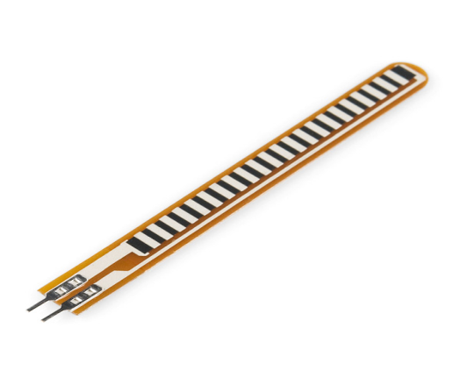

Fig.3 Flex sensor Courtesy: Google images

**Flexion sensors** also called **bend sensors**, measure the amount of deflection caused by bending the sensor. There are various ways of sensing deflection, from strain-gauges to hall-effect sensors. The three most common types of flexion sensors are:

* conductive ink-based
* fibre-optic
* conductive fabric/thread/polymer-based

A property of bend sensors worth noting is that bending the sensor at one point to a prescribed angle is not the most effective use of the sensor. As well, bending the sensor at one point to more than 90˚ may permanently damage the sensor. Instead, bend the sensor around a radius of curvature. The smaller the radius of curvature and the more the whole length of the sensor is involved in the deflection, the greater the resistance will be (which will be much greater than the resistance achieved if the sensor is fixed at one end and bent sharply to a high degree).

**Features**

A typical bend sensor has the following basic specifications:

* Range of deflection
* Uni- vs. bi-directional sensing
* Uni- vs. bi-polar sensing
* Range of resistance (nominal to full-deflection)

**Range of deflection*:*** Determines the maximum angle of deflection that can be measured (as opposed to the maximum angle the sensor can be bent).

**Uni- vs. bi-directional sensing:** Some flexion sensors increase the resistance when bent in either of two opposing directions, however there is no difference in the measurement with respect to the direction.

**Uni- vs. bi-polar sensing:** A bi-polar flexion sensor measures deflection in two opposing directions yielding different measurements.

**Range of resistance:** Bend sensors can vary largely (even the same product) in terms of their range of resistance, measured as the difference from nominal resistance to resistance at full deflection.

**Types of Flex Sensors**

**Conductive Ink based:**These types of bend sensors are passive resistive devices typically fabricated by laying a strip of resistive ink on a flexible plastic substrate, shaped as a thin, flexible stripe in lengths between 1” and 5”. At rest (when laid flat), the bend sensor is characterized by an intrinsic resistance. As the sensor is bent, the resistive materials inside it are pulled further apart. Fewer adjacent resistive particles come into contact, thereby increasing the resistance. Typically, the nominal resistance lays between 10kΩ and 50kΩ and increases by a factor of 10 at full deflection. The resistance can be converted into a voltage.

Within the layers of the flex sensor substrate is a printed pattern of conductive ink. To conduct electricity, this ink contains carbon, or silver, particles mixed into a pigmented medium. Typically, the carbon particles are suspended in the ink to avoid fading of the pigment over time. This type of ink can also be safely applied to paper to avoid absorption into the fibers, thus changing the paper’s properties.

**Fiber Optic:** Fiber-optic bend sensors (also called optical goniometers) consist of a light source, a plastic optical fibre (POF) with an abraded section and a photosensitive detector. Light is emitted into the POF at one end and sensed at the other end. Bending the optical fibre results in a loss of light (intensity). The loss of light is often enhanced by cutting, polishing or abrasing a part of the POF. Due to the sensing principle single fiber-optical bend sensors are uni-polar devices. A bend sensor can also be made from a length of fiber optic cable with an LED and a photodiode placed at both ends of a section of cable.

**Conductive Fabric/Polymer based:** Conductive fabric-, thread- or polymer-based flexion sensors typically consist of two layers of conductive material with a layer of resistive material (e.g. Velostat) in between. It is mostly sandwiched in between layers of more rugged material, e.g. Neoprene. As pressure is applied (directly or by bending) the two layers of conductive material get pushed closer together and the resistance of the sensor decreases. This sensing mechanism is similar to force-sensitive sensors. These types of sensors are pressure sensors which also sense deflection (pressure as a function of deflection): bending the sensor across an angle of a rigid structure results in stretch of the sensor material which exerts pressure onto the sensor. It is this pressure that is measured. Foam/Polymer-based sensors decrease their nominal resistance as the material is compressed. These sensors are known to have poor accuracy, repeatability and hysteresis.

**Comparison**

The characteristic features of the above types of sensors can be summarized in compliance as follows:

|  |  |  |
| --- | --- | --- |
| CONDUCTIVE INK | FIBER-OPTIC | FABRIC/POLYMER |
| + robust & durable | + accurate, repeatable measurements | + attractive physical qualities |
| - fixed lengths, drift | - requires light-source & detector | - poor & variable performance |

**Mechanical Specifications:**

* **Life cycle:**> 1 million bends
* **Height:**< 0.44mm
* **Temperature range:** -35°Cto +80 °C

**Electrical Specifications:**

* **Flat resistance:** 25K Ohms
* **Resistance tolerance:** 30%
* **Bend resistance:** 45K – 125K Ohms
* **Power rating:** 1 watt (peak)

**Schematics**

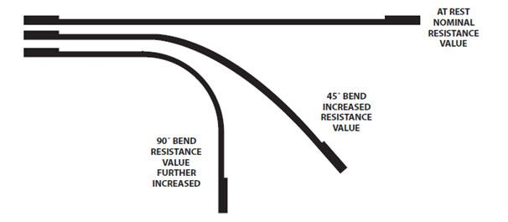

Fig. 4 working of flex sensor Courtesy: Google images

* **ACCELEROMETER[5] :**

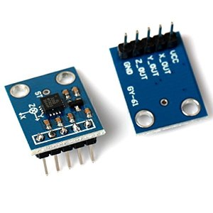

Fig. 5 Accelerometer Courtesy: Google images

Accelerometers are devices that measure acceleration, which is the rate of change of the velocity of an object. They measure in meters per second squared (m/s2) or in G-forces (g). A single G-force for us here on planet Earth is equivalent to 9.8 m/s2, but this does vary slightly with elevation (and will be a different value on different planets due to variations in gravitational pull). Accelerometers are useful for sensing vibrations in systems or for orientation applications.

**FEATURES**

* 3-axis sensing
* Small, low profile package
* 4 mm × 4 mm × 1.45 mm LFCSP
* Low power : 350 μA (typical)
* Single-supply operation: 1.8 V to 3.6 V
* 10,000 g shock survival
* Excellent temperature stability

**Pin Function Descriptions**

|  |  |  |
| --- | --- | --- |
| PIN NO. | PIN NAME | DESCRIPTION |
| 1 | VCC | Supply Voltage.1.8-5v |
| 2 | X-OUT | X Channel Output |
| 3 | Y-OUT | Y Channel Output |
| 4 | Z-OUT | Z Channel Output |
| 5 | GND | Supply Ground |

**Specifications**

* **Operating voltage range:** 1.8 - 5 V
* **Supply current:** 350uA
* **Operating temperature:**-40° °C to +85°C
* **Interfaces:** Analog
* **Dimensions:** 20.3mm×15.7mm×11.6mm
* **No. of axis:** 3

**[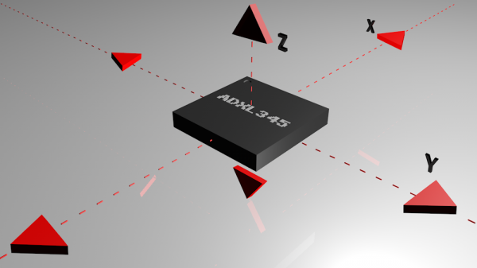](https://cdn.sparkfun.com/assets/6/7/e/5/a/516c6b6ece395f0f49000000.jpeg)**

Fig. 6Axis measurement of accelerometer Courtesy: Google images

## How an Accelerometer Works

Accelerometers are electromechanical devices that sense either static or dynamic forces of acceleration. Static forces include gravity, while dynamic forces can include vibrations and movement.

Accelerometers can measure acceleration on one, two, or three axes. 3-axis units are becoming more common as the cost of development for them decreases.

Generally, accelerometers contain capacitive plates internally. Some of these are fixed, while others are attached to miniscule springs that move internally as acceleration forces act upon the sensor. As these plates move in relation to each other, the capacitance between them changes. From these changes in capacitance, the acceleration can be determined.

Other accelerometers can be centered around piezoelectric materials. These tiny crystal structures output electrical charge when placed under mechanical stress ( e.g. acceleration).

### Range

Most accelerometers will have a selectable range of forces they can measure. These ranges can vary from ±1g up to ±250g. Typically, the smaller the range, the more sensitive the readings will be from the accelerometer. For example, to measure small vibrations on a tabletop, using a small-range accelerometer will provide more detailed data than using a 250g range (which is more suited for rockets).

**Additional Features**

Accelerometers are the stuff of rocket science—quite literally! Mounted in spacecraft, they're a handy way to measure not just changes in rocket speed but also apogee (when a craft is at its maximum distance from Earth or another mass, so its acceleration due to gravity is at a minimum) and orientation (because tilting something changes the way gravity acts on it and the force it feels). Accelerometers are also widely used in **inertial navigation** and guidance systems.

* **LIQUID CRYSTAL DISPLAY (LCD)[4]:**

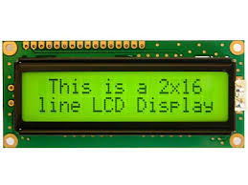

Fig. 7 LCD [16*2] Courtesy: Google images

Alphanumeric displays are used in a wide range of applications, including palmtop computers, word processors, photocopiers, point of sale terminals, medical instruments, cellular phones, etc. The 16 x 2 intelligent alphanumeric dot matrix display is capable of displaying 224 different characters and symbols.

**Specifications**

* **Power voltage:** 0 – 7 V
* **Input voltage:** VSS/VDD
* **Operating temperature:** 0°C to +50°C
* **Storage temperature:** -20°C to +60°C

**Pin Diagram**

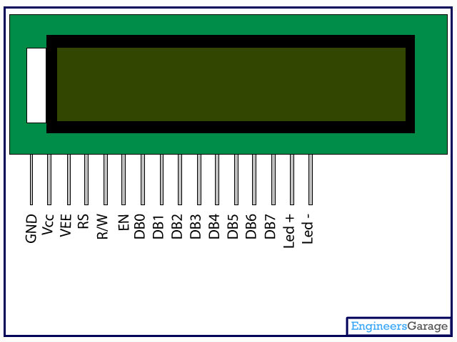

Fig. 8 LCD pin diagram Courtesy: Google images

**[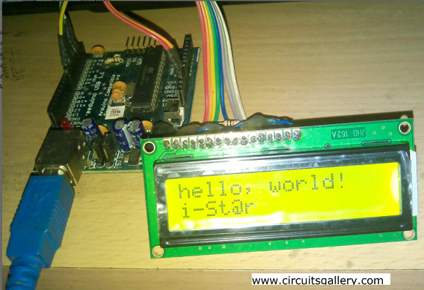](http://www.circuitsgallery.com/wp-content/uploads/2014/10/Arduino-hello-world.png)**

Fig .9 LCD interfacing Courtesy: project

**Pin Specifications**

|  |  |  |
| --- | --- | --- |
| PIN NO | NAME | FUNCTION |
| 1 | VSS | Ground pin |
| 2 | VCC | Power supply pin of 5V |
| 3 | VEE | Used for adjusting the contrast commonly attached to the potentiometer. |
| 4 | RS | RS is the register select pin used to write display data to the LCD (characters), this pin has to be high when writing the data to the LCD. During the initializing sequence and other commands this pin should low. |
| 5 | R/W | Reading and writing data to the LCD for reading the data R/W pin should be high (R/W=1) to write the data to LCD R/W pin should be low (R/W=0) |
| 6 | E | Enable pin is for starting or enabling the module. A high to low pulse of about 450ns pulse is given to this pin. |
| 7 | DB0 |  |
| 8 | DB1 |  |
| 9 | DB2 |  |
| 10 | DB3 |  |
| 11 | DB4 | DB0-DB7 Data pins for giving data(normal data like numbers characters or command data) which is meant to be displayed |
| 12 | DB5 |  |
| 13 | DB6 |  |
| 14 | DB7 |  |
| 15 | LED+ | Back light of the LCD which should be connected to Vcc |
| 16 | LED- | Back light of LCD which should be connected to ground. |

**LCD interfacing with Arduino uno:**

[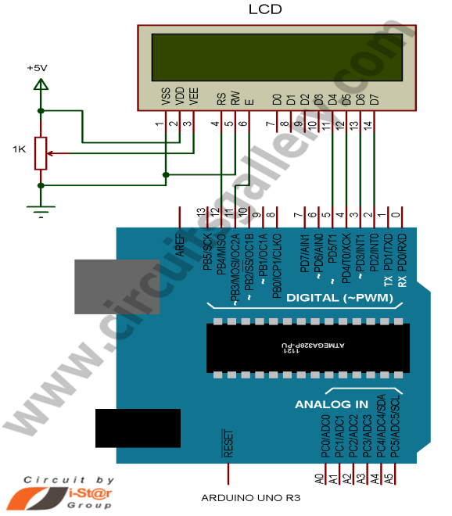](http://www.circuitsgallery.com/wp-content/uploads/2014/10/Interfacing-LCD-with-Arduino-.png)

Fig. 10 Interfacing of LCD with Arduino Courtesy: Google images

**PROJECT APPROACH**

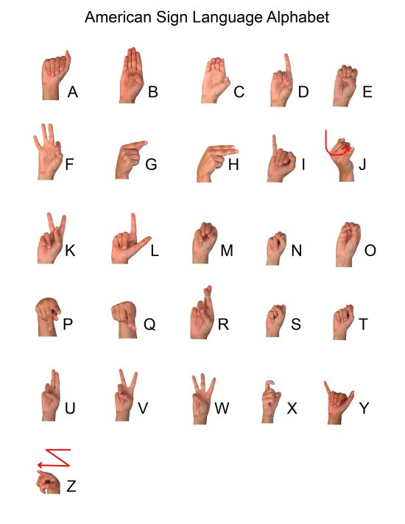

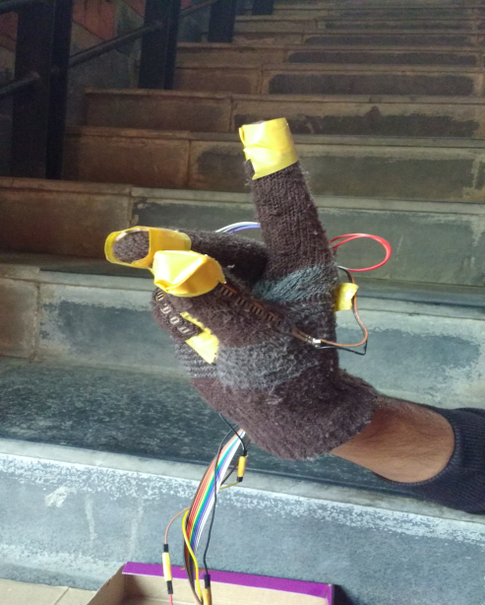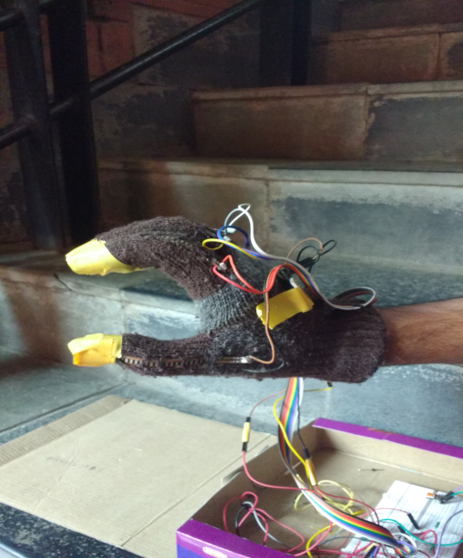

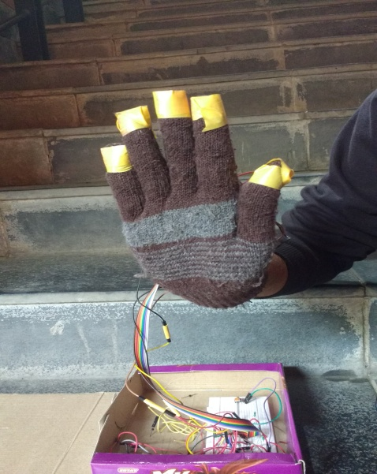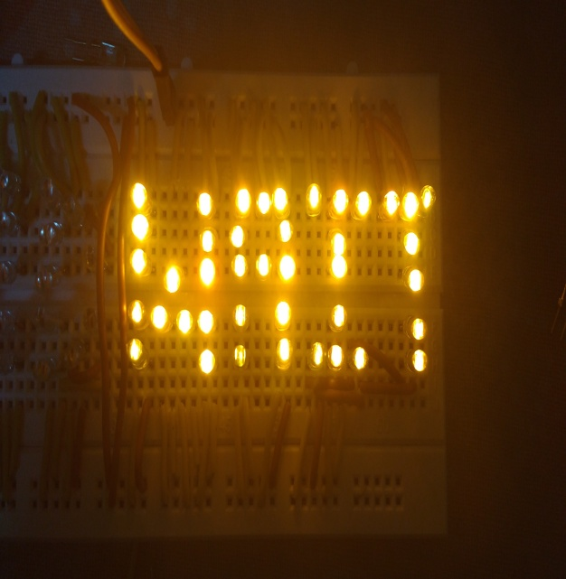

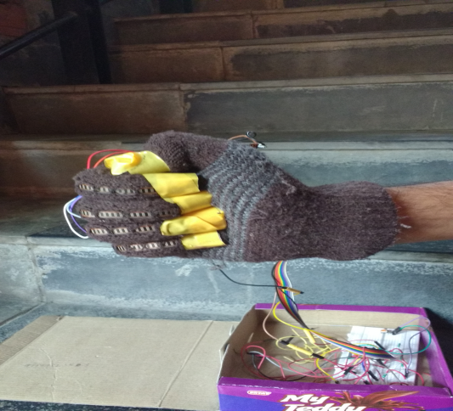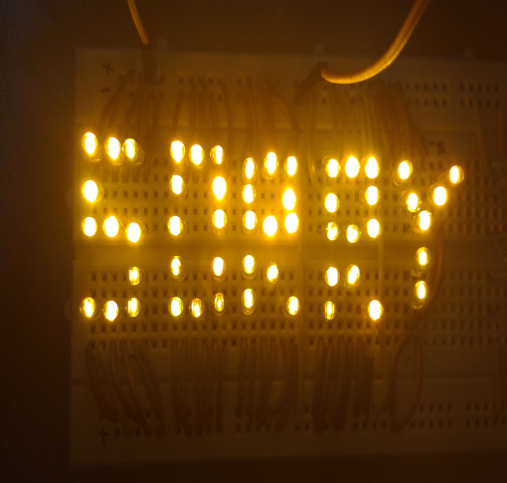

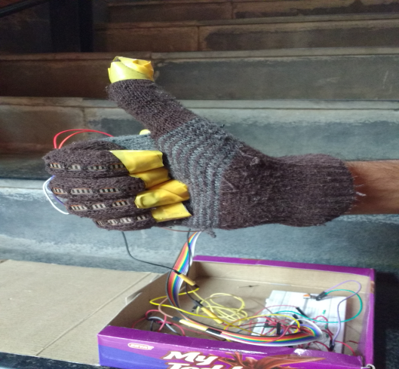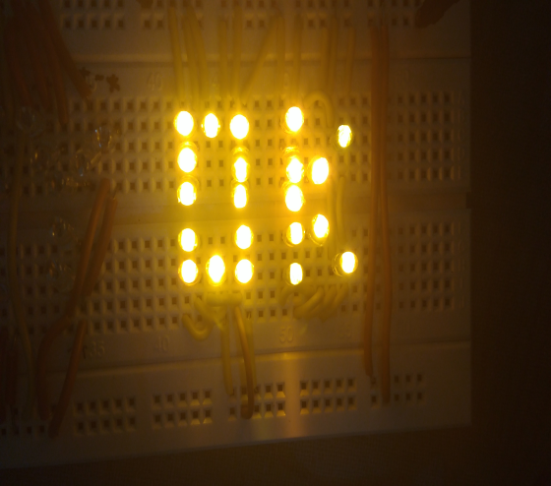

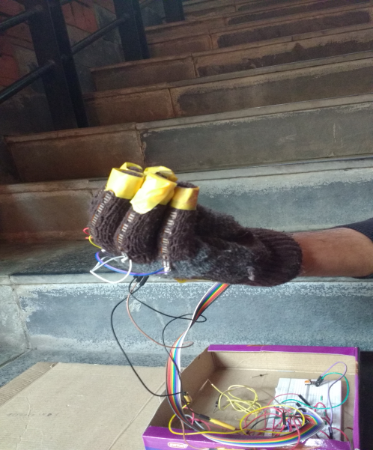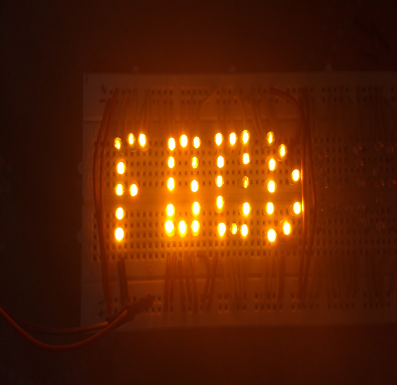

**BUDGET & COST ESTIMATION**

|  |  |  |  |  |
| --- | --- | --- | --- | --- |
| S.NO | COMPONENT | QUANTITY | COST PER PIECE | TOTAL COST |
| 1. | Arduino | 1 | Rs.450 | Rs.450 |
| 2. | Flex sensor | 5 | Rs.400 | Rs.2000 |
| 3. | Accelerometer | 1 | Rs.180 | Rs.180 |
| 4. | LCD | 1 | Rs.90 | Rs.90 |
| 5. | LED | 200(approx) | Rs.0.70 | Rs.140 |
| 6. | Printing cost | -- | -- | Rs.280 |
|  |  |  |  |  |
|  |  |  | **TOTAL** | **Rs.3140** |
|  |  |  |  |  |

Total Cost = Cost of components + Indirect cost

= Rs 3140 + Rs 300 (approx) = Rs 3440

Final Cost = Total Cost – (Cost Of equipment we already had)

= Rs3440 – Rs 540 (approx) = Rs2900

**APPLICATIONS**

The concept of this project aims to make communication easy for deaf and dumb people. It gives a easy way of translating the sign language into respective alphabets of English language. This system is much more convenient as well as cheap than the previous systems which were made using the image processing techniques. Moreover, this system is more compact and mobile as compared to previous systems, it can be carried from one place to another with ease.

**FUTURE SCOPE**

Currently, this project has been made using the flex sensors which gives better results than the previous techniques. This project can be modified for many daily life applications such as in gaming, robotics, medical components, computer peripherals etc.

Moreover, in future this project can also be improvised by using any other kind of sensors and techniques for more accuracy and precision.

**CONCLUSION**

This project has successfully presented a functional method of **“Sign Language Interpretation**” for deaf and dumb people. The system is designed using Arduino, flex sensors, accelerometer and many other components. The key objective of this project is to develop a communication method for deaf and dumb people keeping in mind the complexity and cost of the system. Earlier communication aid systems (for deaf and dumb people) were built using MATLAB and Image Processing technique which was expensive and cumbersome for the patient. This system is quite cheap, easy and compact and gives better results as compared to the previous systems.

In the conclusion we consider how this system can be further improved in future, may be by adding new type of sensors as well as using new approaches to develop a better communication aid for deaf and dumb people .

**REFERENCES**

1. <http://www.atmel.com/images/atmel-8271-8-bit-avr-microcontroller-atmega48a-48pa-88a-88pa-168a-168pa-328-328p_datasheet_complete.pdf> - October, 2014
2. <https://www.sparkfun.com/datasheets/Sensors/Flex/flex22.pdf> - June, 2010
3. <http://www.farnell.com/datasheets/1682209.pdf>
4. <https://www.sparkfun.com/datasheets/LCD/ADM1602K-NSW-FBS-3.3v.pdf> - October, 2008
5. <http://www.thaieasyelec.com/downloads/ESEN241/ADXL335.pdf> - 2009
6. International Journal of Scientific and Research Publications, Volume 4, Issue 11, November 2014
7. IEEE Sensors journal, Volume 12, No. 5, May 2012